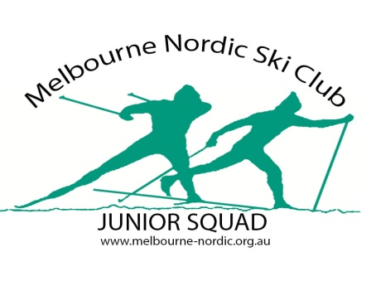
MNSC Junior Program: Registration, Medical & Parent Consent Form

First Name..................................................................Surname...................................................................................

Age.................................................................... ........Date of Birth.............................................................................

Address.......................................................................................................................................................................

....................................................................................................................................................................................

Mobile Phone................................................................Other Phone.........................................................................

Parent/Guardian Email Address..................................................................................................................................

Emergency Contact Name & Phone.............................................................................................................................

Please give details of any significant medical conditions, injuries or allergies that we should know about:

....................................................................................................................................................................................

....................................................................................................................................................................................

....................................................................................................................................................................................

....................................................................................................................................................................................

....................................................................................................................................................................................

Consent to Medical Attention: I authorise the person in charge of the training session to consent where it is impracticable to communicate with me for my child to receive medical treatment as may be deemed necessary.

....................................................................................................................................................................................
_{Parent / Guardian Signature}

Photo Release Permission: I give permission for any photos or digital images taken during club activities to be available for reproduction or publication in any format for the purposes of club promotion by Melbourne Nordic Ski Club.

....................................................................................................................................................................................
_{Parent / Guardian Signature}

Protective helmets and gloves must be worn during rollerski/skike activities. Other protective gear including knee and elbow pads are strongly recommended. Athletes and parents must accept the risks inherent in the junior training program. Everyone must agree to participate in activities in a way that minimises risk to all. Any parent or athlete found in violation of MNSC rules may be asked to leave training immediately.

Parental Participation Consent: I agree to accept the risks inherent in the junior training program and I give consent for my child to participate in the MNSC training program.

....................................................................................................................................................................................
_{Parent / Guardian Signature} _{Print Name} _{date}

